Source Data Mapping Approach to CDMV5.4

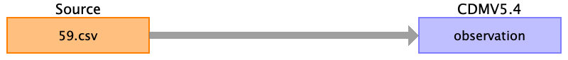

Table name: person

Table name: observation_period

Table name: visit_occurrence

Table name: visit_detail

Table name: condition_occurrence

Table name: drug_exposure

Table name: procedure_occurrence

Table name: device_exposure

Table name: measurement

Table name: observation

Reading from 59.csv

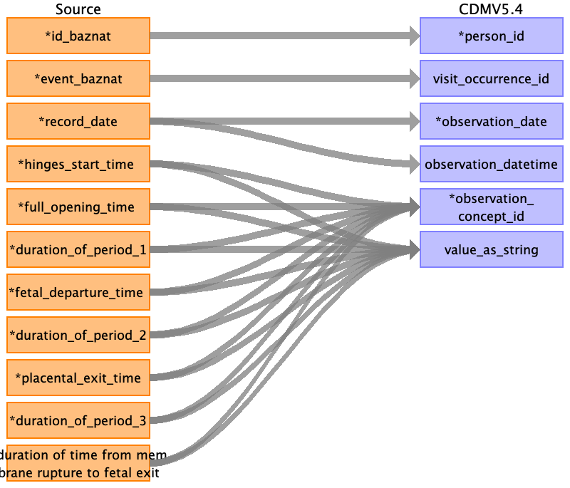

|  |  |  |  |
| --- | --- | --- | --- |
| Destination Field | Source Field | Logic | Comment |
| observation_id |  |  |  |
| person_id | ﻿id_baznat |  |  |
| visit_occurrence_id | event_baznat |  |  |
| observation_date | record_date |  | Only date DD/MM/YYYY |
| observation_datetime | record_date |  | Date and time - DD/MM/YYYY HH:MM:SS |
| observation_concept_id | hinges_start_time  full_opening_time  duration_of_period_1  fetal_departure_time  duration_of_period_2  placental_exit_time  duration_of_period_3  duration of time from membrane rupture to fetal exit |  | Set HINGES_START_TIME = 249123005  Set FULL_OPENING_TIME = 249160009  Set DURATION_OF_PERIOD_1 = 169821004  set FETAL_DEPARTURE_TIME = 397836004  Set DURATION_OF_PERIOD_2 = 169822006 |
| value_as_string | hinges_start_time  full_opening_time  duration_of_period_1  fetal_departure_time  duration of time from membrane rupture to fetal exit  duration_of_period_3  placental_exit_time  duration_of_period_2 |  | Value from source table. |
| value_as_number |  |  | Not use in this field. |
| observation_type_concept_id |  |  | EHR_CONCEPT_ID = 32817 |
| value_as_concept_id |  |  | Not use in this field. |
| qualifier_concept_id |  |  | Not use in this field. |
| unit_concept_id |  |  | According to visit_detail_id |
| provider_id |  |  | Not use in this field. |
| visit_detail_id |  |  | According to visit_occuerrence id and time. |
| observation_source_value |  |  | Not use in this field. |
| observation_source_concept_id |  |  | Not use in this field. |
| unit_source_value |  |  | Not use in this field. |
| qualifier_source_value |  |  | Not use in this field. |
| value_source_value |  |  | Not use in this field. |
| observation_event_id |  |  | Not use in this field. |
| obs_event_field_concept_id |  |  | Not use in this field. |

Table name: death

Table name: note

Table name: note_nlp

Table name: specimen

Table name: fact_relationship

Table name: location

Table name: care_site

Table name: provider

Table name: payer_plan_period

Table name: cost

Table name: drug_era

Table name: dose_era

Table name: condition_era

Table name: episode

Table name: episode_event

Table name: metadata

Table name: cdm_source

Table name: cohort

Table name: cohort_definition

Appendix: source tables

Table: 59.csv

|  |  |  |  |
| --- | --- | --- | --- |
| Field | Type | Most freq. value | Comment |
| ﻿id_baznat | INT |  |  |
| event_baznat | INT |  |  |
| record_date | INT |  |  |
| unit | INT |  |  |
| hinges_start_time | INT |  |  |
| full_opening_time | INT |  |  |
| duration_of_period_1 | INT |  |  |
| fetal_departure_time | INT |  |  |
| duration_of_period_2 | INT |  |  |
| placental_exit_time | INT |  | Set PLACENTAL_EXIT_TIME = 249169005 |
| duration_of_period_3 | INT |  | Set DURATION_OF_PERIOD_3 = 169823001 |
| membranes_time | INT |  |  |
| duration of time from membrane rupture to fetal exit | INT |  | Set MEMBRANES_TIME = 289251005 |